Breadth-First Search (BFS)

AIM: To write a Python program to implement Breadth-First Search for traversing a graph level by level.

Algorithm:
- Start the program.
- Initialize the graph, starting node, and an empty visited set.
- Insert the starting node into a queue and mark it as visited.
- Remove the front node from the queue.
- Display or process the removed node.
- Add all unvisited adjacent nodes to the queue and mark them as visited.
- Repeat Steps 4–6 until the queue becomes empty or the target node is found.
- Display the traversal order.
- Stop the program.

Code :
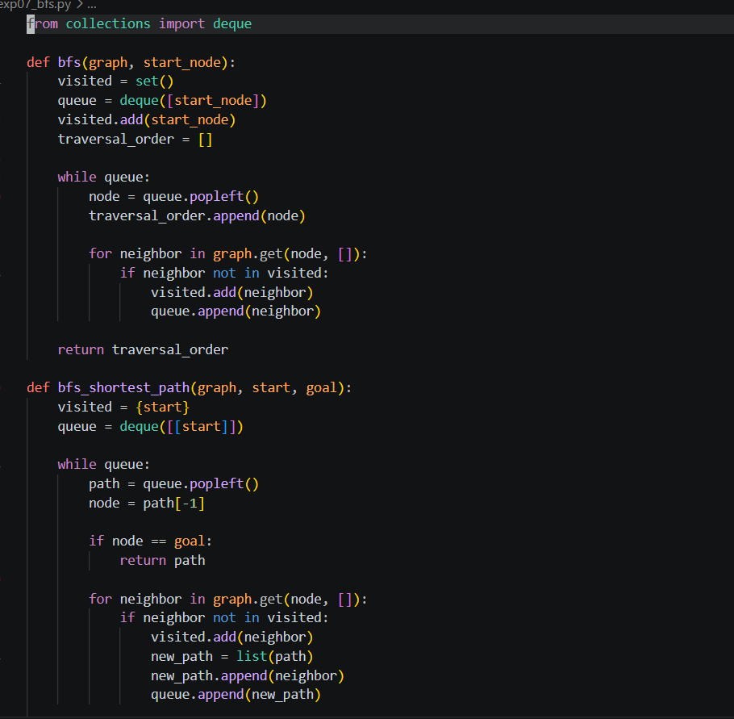

Output :
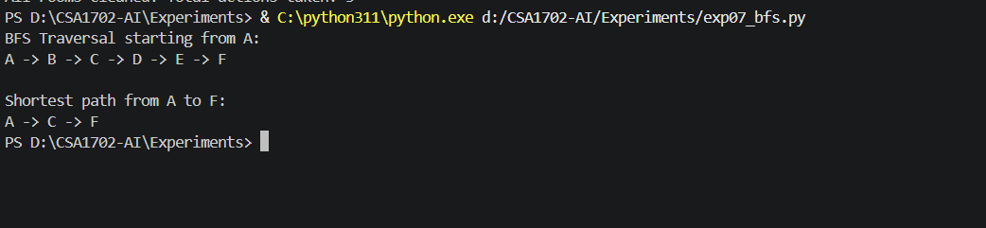
Result :
Thus, the Python program to implement Breadth-First Search (BFS) was executed successfully.

